Natural Biodiversity Promotion in Diversified Organic Rice Farming Systems in Northern Italy

Michele Salvan^{1,2*}, Giuseppe Desantis², Matteo Petitti², Daniela Ponzini², Rachele Stentella², Riccardo Bocci², Irene Piccini¹, Simona Bonelli¹

¹University of Turin
² Rete Semi Rurali

Reconciling natural biodiversity conservation with agro-ecosystems is a current challenge for sustainable food systems.
Organic rice production is increasing in Italy, promoting biodiversity, both in terms of rice genetic resources and at ecosystem level. Rice fields can be considered as wetland areas substitutes, crucial as biodiversity hotspot, and thus representing natural or semi-natural habitats within intensively farmed districts. Their ecological role and value increases, when combined with agro-ecological farming practices, including cultivar diversification through rice mixtures and dynamic populations.
To assess natural biodiversity in rice farming contexts, we developed a pool of entomological and botanical indicators, focusing on pollinators’ ecosystems services, biodiversity stock and wetlands preservation. Insects can be targeted as environmental indicators, since they are relatively easy to monitor and provide an accurate picture of the health of the environment throughout the rice cultivation cycle.
Lepidoptera and Odonata Orders in particular were used as main natural biodiversity and ecosystem services proxy in rice farming systems. Species richness and individuals’ abundance per species were correlated with environmentally-related variables, such as natural habitats proximity, water quality and farm management practices, both under organic and conventional conditions.
Rice fields’ role as wetland areas substitutes has been studied and evaluated according to farming practices sustainability, within and around rice fields.
We argue, that entomological monitoring can be integrated in organic farming appraisal, to quantify crop and natural diversification. This data, correlated with biodiversity-friendly practices on a scalable field, farm or district/landscape level, could become a useful tool to weigh the measured benefits of biodiversity-friendly rice management practices and related ecosystem services, such as pollination, against the extra economic costs that these entail.
Agro-ecological rice farming system, paired with increased cultivated diversity – including rotations, rice cultivar diversification and rice mixtures – can improve food systems’ resilience against abiotic and biotic stresses caused by climate change and enhance natural biodiversity and resilience at both farm and landscape scale.

Key words: organic rice farming, organic heterogeneous materials, rice mixtures, wetlands, natural biodiversity, environmental indicators, climate change.

*Corresponding author: Michele Salvan
Position: PhD student
Affiliations: University of Turin and Rete Semi Rurali
Country: Italy
E-mail: michele.salvan@rsr.bio

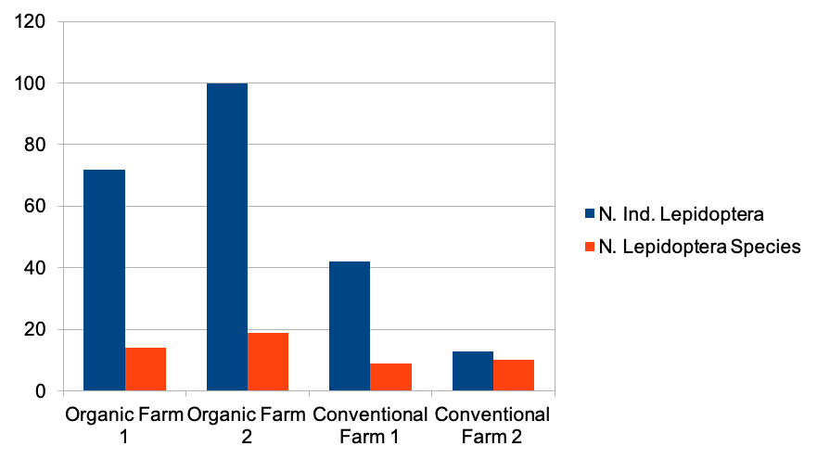
Fig.1: Lepidoptera abundance and species richness in neighbouring organic and conventional farms. Organic farms contain decidedly more Lepidoptera’s individuals compared to control conventional farms. Species richness however is more influenced by surrounding environmental context compared to Lepidoptera’s Abundance.

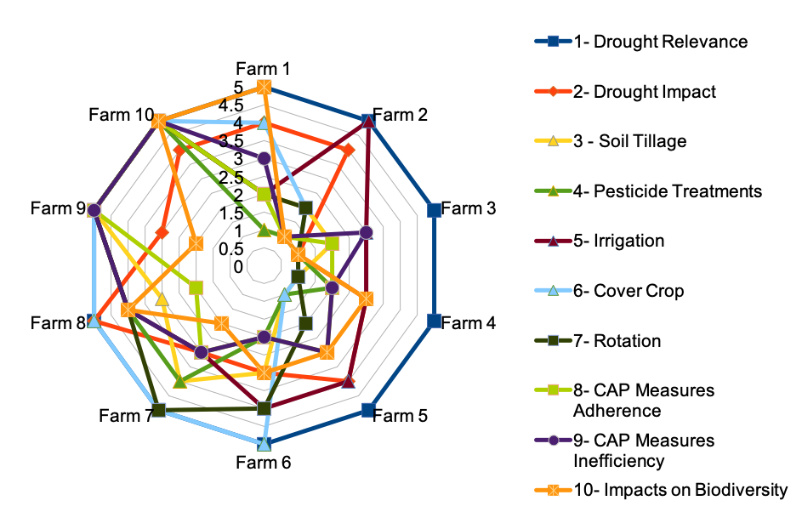
Fig. 2: Environmental impacts radar chart of organic (1-5) and conventional farms (6-10).
Organic farms (left part of the chart) show clearly inferior environmental impacts compared to their conventional counterparts (right part of the chart).

